Case Study Report

# Tech Saksham



Data Analytics with Power BI

**“IPL ANALYSIS USING POWER BI”**

**“Government Arts And Science College, Gudalur”**

|  |  |
| --- | --- |
| **NM ID** | **NAME** |
| C17582DDD4B2285A38049734EC00FB61 | **VIGNESHWARAN D** |

Trainer Name: R UMAMAHESWARI Master Trainer: R UMAMAHESWARI

## ABSTRACT

This study utilizes Power BI to analyze Indian Premier League (IPL) data, focusing on player performance, team dynamics, match outcomes, and financial implications. By scrutinizing player statistics and team metrics across multiple seasons, it identifies standout performers, assesses team strategies, and uncovers performance trends. Additionally, it explores the correlation between on-field performance and off-field factors like sponsorships and viewership, providing actionable insights for stakeholders to optimize decision-making and enhance fan engagement within the IPL ecosystem. The Indian Premier League (IPL) stands as one of the most captivating and commercially successful cricket leagues globally, attracting millions of fans and significant investments from stakeholders. With its blend of athleticism, entertainment, and business acumen, the IPL serves as a rich ground for data-driven analysis. This study employs Power BI, a powerful business analytics tool, to dissect various dimensions of IPL data encompassing player performance, team dynamics, match outcomes, and financial implications.

**INDEX**

|  |  |  |
| --- | --- | --- |
| **Sr. No.** | **Table of Contents** | **Page No.** |
| 1 | Chapter 1: Introduction | 4 |
| 2 | Chapter 2: Services and Tools Required | 6 |
| 3 | Chapter 3: Project Architecture | 7 |
| 4 | Chapter 4: Modeling and Result | 9 |
| 5 | Conclusion | 18 |
| 6 | Future Scope | 19 |
| 7 | References | 20 |
| 8 | Links | 21 |

**CHAPTER 1**

### INTRODUCTION

#### 1.1 Problem Statement

The Indian Premier League (IPL) boasts a wealth of data across player performance, team dynamics, match outcomes, and financial metrics, yet extracting actionable insights remains a challenge for stakeholders. Traditional analysis methods struggle to integrate diverse datasets and uncover meaningful patterns. This study aims to leverage Power BI to address this challenge by streamlining IPL data analysis. Key issues include integrating disparate data sources, handling complex analysis requirements, and providing timely insights to support strategic decisionmaking. By tackling these challenges, the study seeks to demonstrate Power BI's potential in optimizing IPL insights, empowering stakeholders to make informed decisions in this dynamic and competitive sporting environment.

#### 1.2 Proposed Solution

The proposed solution involves leveraging Power BI to streamline IPL data analysis, addressi ng the challenges of integrating diverse datasets and extracting actionable insights. By utilizing Power BI's advanced analytics capabilities, stakeholders can gain a comprehensive view of IPL data, including player performance, team dynamics, match outcomes, and financial metrics. This solution aims to provide timely and actionable insights to support strategic decision-making across various aspects of the IPL ecosystem, including player recruitment, team composition, match strategy, fan engagement, and revenue generation. Through this approach, stakeholders can harness the power of data to optimize performance, engagement, and profitability within the dynamic and competitive landscape of the Indian Premier League.

#### 1.3 Feature

* Integrate a predictive model into your dashboard that forecasts match outcomes based on historical data and various match-related factors.
* Incorporate the predictive model's results into your dashboard to provide users with insights into the expected outcomes of upcoming matches.
* Visualize the predicted match results alongside actual outcomes, allowing users to compare and assess the model's accuracy over time.

#### 1.4 Advantages

* **Enhanced Decision-Making:** Users can make informed decisions regarding betting, fantasy league selections, or team strategies based on predicted match outcomes.
* **Increased Engagement:** Predictive features add an interactive element to the dashboard, increasing user engagement and encouraging return visits.
* **Real-Time Insights:** By updating the predictive model with the latest data, users gain access to real-time insights and can adjust their strategies accordingly.

#### 1.5 Scope

The scope of analyzing IPL data using Power BI involves a multifaceted approach to exploring various aspects of the tournament. It encompasses the collection and integration of diverse datasets, including player statistics, match results, team performance metrics, and venue information. Through data preprocessing, modeling, and visualization techniques within Power BI, this analysis aims to uncover insights into player performance trends, team strategies, match dynamics, and the influence of factors such as pitch conditions and player form on match outcomes. Additionally, the scope extends to comparative analyses between teams and players, trend identification across multiple IPL seasons, and the identification of actionable insights to support decision-making for players, teams, coaches, and stakeholders within the cricketing community.

**CHAPTER 2**

### SERVICES AND TOOLS REQUIRED

#### 2.1 Services Used

**Power BI Desktop:** This is the primary tool for data visualization and analysis, allowing users to connect to various data sources, create data models, and design interactive reports and dashboards tailored to IPL data.

**Data Sources:** Diverse data sources such as official IPL websites, cricket statistics databases, and datasets from platforms like Kaggle are used to gather IPL-related data. These sources provide the raw data necessary for analysis within Power BI.

**Azure Services:** Microsoft Azure offers a suite of cloud services that complement Power BI for advanced analytics tasks and data processing. Services like Azure Blob Storage for data storage, Azure SQL Database for data management, and Azure Machine Learning for predictive analytics can be integrated into the IPL analysis workflow, enhancing the depth and breadth of insights derived from the data.

#### 2.2 Tools and Software used

**Tools**:

* **Power BI**: The main tool for this project is Power BI, which will be used to create interactive dashboards for real-time data visualization.

* **Power Query**: This is a data connection technology that enables you to discover, connect, combine, and refine data across a wide variety of sources.

**Software Requirements**:

* **Power BI Desktop**: This is a Windows application that you can use to create reports and publish them to Power BI.

* **Power BI Service**: This is an online SaaS (Software as a Service) service that you use to publish reports, create new dashboards, and share insights.

### CHAPTER 3

**PROJECT ARCHITECTURE**

#### 3.1 Architecture



Data

preparation



Data

Sources



Power

BI

Desktop



Power

BI

Services



Data

Modeling

And

Analysis

Here’s a high-level architecture for the project:

1. **Data Sources:** The architecture begins with various data sources containing IPLrelated information. These sources may include official IPL websites, cricket statistics databases, CSV files, APIs, or datasets from platforms like Kaggle. Data sources provide raw data such as match results, player statistics, team performance metrics, and venue information.
2. **Data Preparation:** Once the data sources are identified, the next step is to prepare the data for analysis. This involves data cleaning, transformation, and structuring to ensure that the data is in a suitable format for analysis within Power BI. Tools such as Excel, Python, or SQL Server may be used for data preprocessing tasks.
3. **Power BI Desktop:** Power BI Desktop serves as the primary tool for data visualization and analysis. Users connect to the prepared data sources within Power BI Desktop, import the data, and create a data model that defines the relationships between different data entities such as matches, players, teams, and venues.
4. **Data Modeling:** Within Power BI Desktop, users define relationships between tables, create calculated columns and measures, and perform data modeling tasks to prepare the data for analysis. This step ensures that the data is structured in a way that facilitates meaningful analysis and visualization.
5. **Power BI Service:** After creating reports and dashboards in Power BI Desktop, users can publish them to the Power BI Service, which is a cloud-based platform for sharing and collaboration. The Power BI Service allows users to share reports and dashboards with stakeholders, schedule data refreshes to keep the analysis up-to-date, and access reports from web browsers or mobile devices.

### CHAPTER 4

**MODELING AND RESULT**

**Manage relationship**

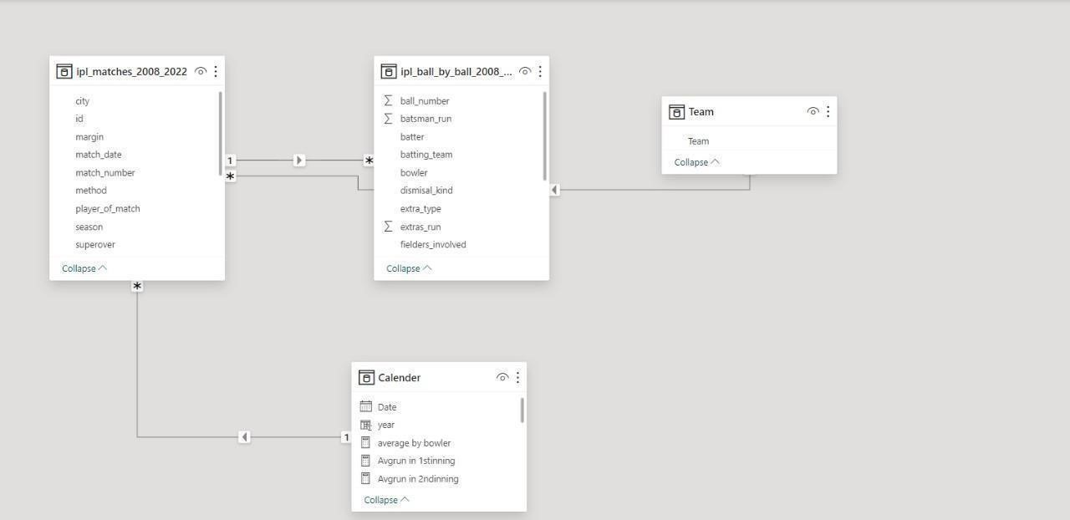

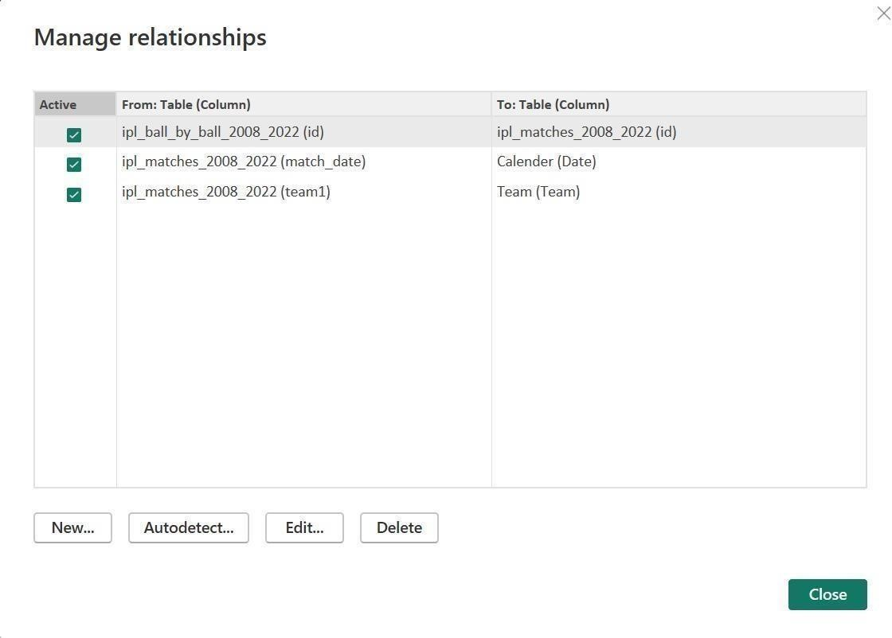

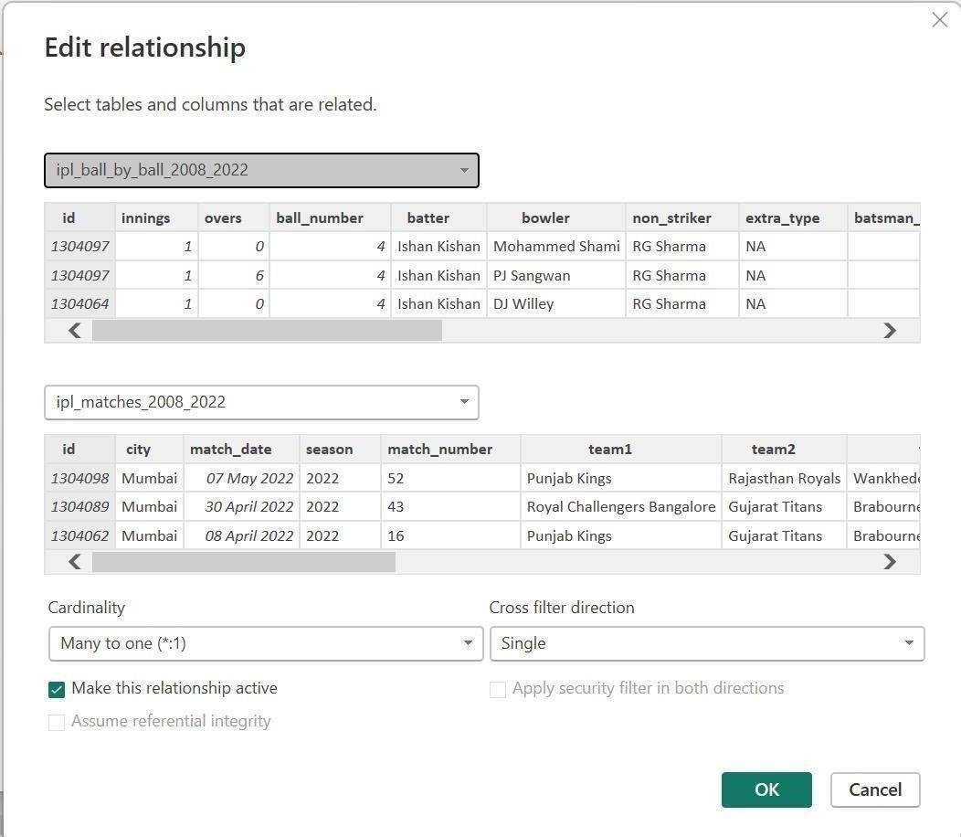

### Dashboard

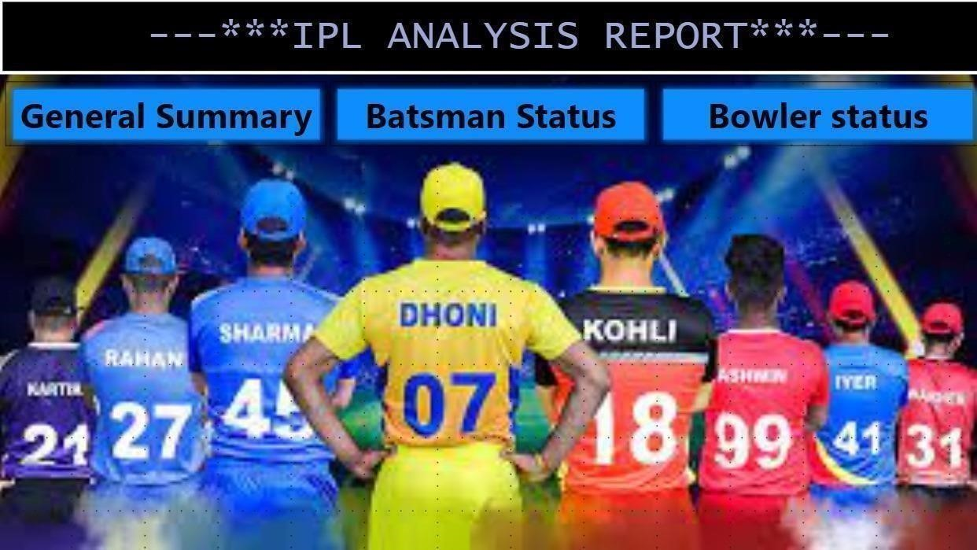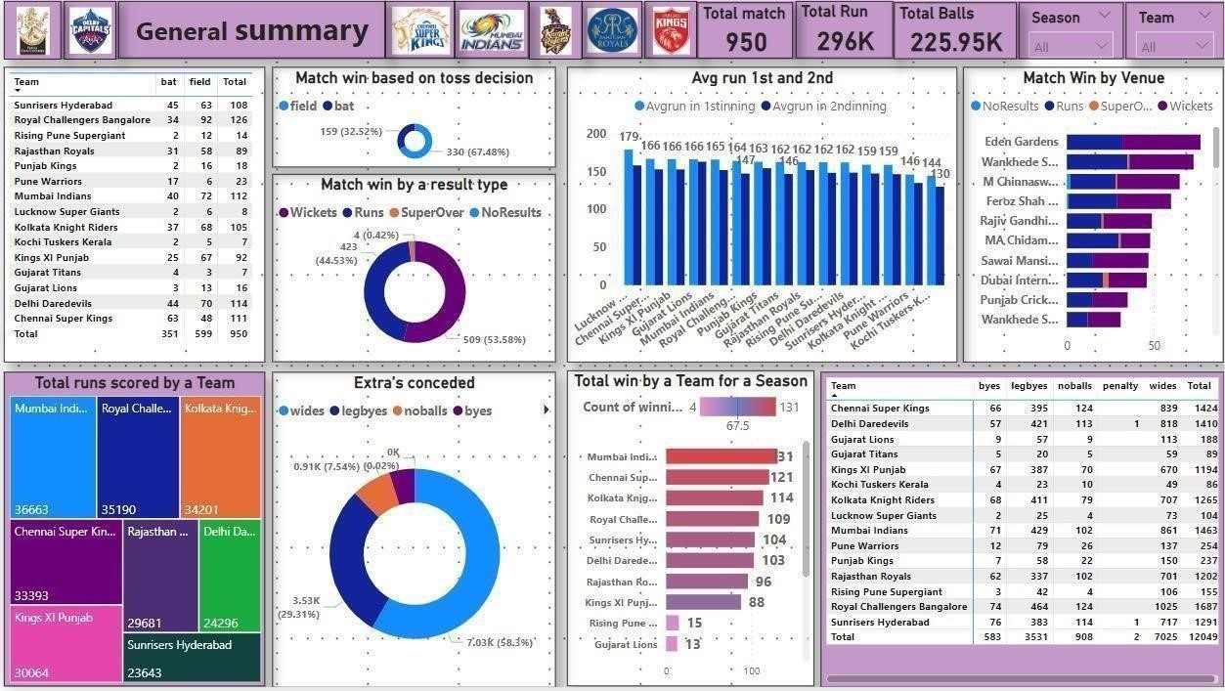

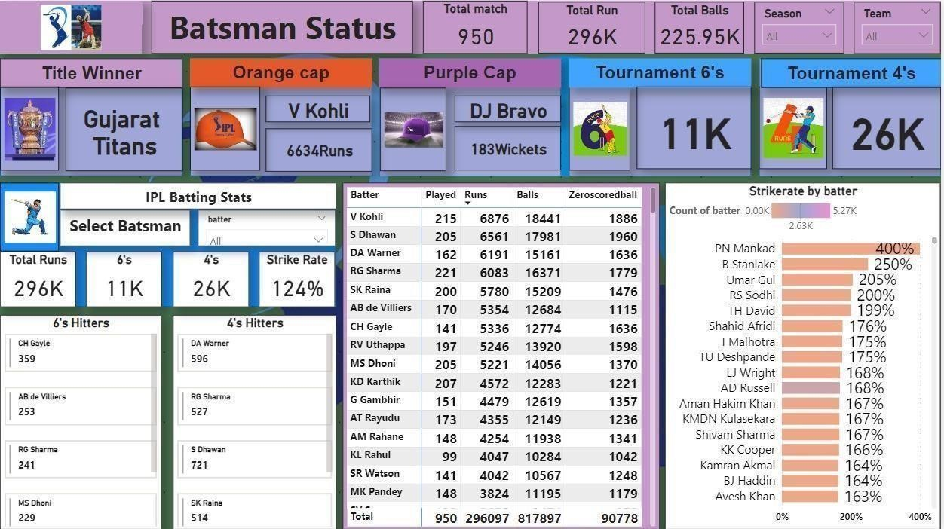

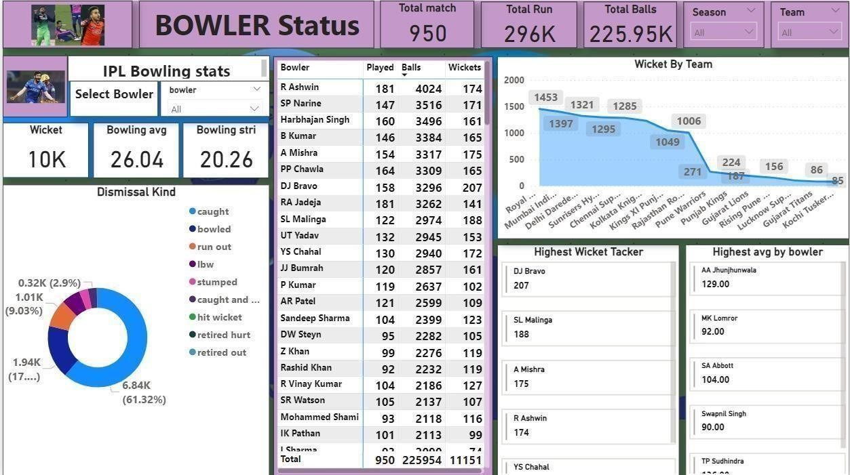

#### CONCLUSION

In conclusion, analyzing IPL data using Power BI offers a powerful approach to gaining insights into player performance, team dynamics, and match outcomes within the Indian Premier League. By leveraging diverse data sources and employing data preparation, modeling, and visualization techniques, analysts can uncover valuable trends, patterns, and correlations that inform decision-making for players, teams, coaches, and stakeholders. The architecture outlined facilitates a structured workflow from data collection and preparation to visualization and analysis, with options for further enhancement through integration with Azure services. Ultimately, this approach empowers stakeholders within the cricketing community to make informed decisions, optimize strategies, and enhance performance within the dynamic and competitive landscape of the IPL.

#### FUTURE SCOPE

The future scope for analyzing IPL data using Power BI is promising, with opportunities for advanced analytics, real-time data analysis, enhanced visualization, integration with IoT and wearable technology, fan engagement analysis, and cross-sport collaboration. By incorporating predictive modeling, machine learning, and sentiment analysis, teams can gain deeper insights into match outcomes and player performance, facilitating proactive decision-making. Real-time data streaming capabilities can enable agile monitoring of match dynamics, while innovations in visualization and interactivity can enhance user experiences and facilitate immersive exploration of IPL data. Integration with IoT sensors and wearable technology presents avenues for optimizing player health and performance, while analysis of fan engagement metrics and social media sentiment can inform marketing strategies and revenue generation. Additionally, crosssport analysis and collaboration offer opportunities for comparative analysis and knowledge sharing across different sporting disciplines, driving innovation and excellence within the IPL and the broader cricketing community.

#### REFERENCES

[https://medium.com/@therealbhuvi/end-to-end-ipl-data-analysis-with-python-and-power-bi-695d283b61ea](https://medium.com/%40therealbhuvi/end-to-end-ipl-data-analysis-with-python-and-power-bi-695d283b61ea)

#### LINK

<https://github.com/BELLBUTLI52/Naan-mudhalvan-case-study-.git>